LAB MANUAL
PART B
(PART B: TO BE COMPLETED BY STUDENTS)

Roll. No: C60 | Name: Avdhut Parish Madhavi
Class: C(SE-COMPS) | Batch: C2
Date of Experiment: | Date of Submission:
Grade:

B.1: Read the given question carefully and write a SQL statement and check the output.
(Put the query and its output after each question.)
Form a group of 2–3 students and perform the following tasks:

- Identify and define a clear problem statement

GYM MANAGEMENT SYSTEM – Brief Description

A Gym Management System is a database-based application used to manage information about gym members, trainers, memberships, and workouts in a centralized database. It stores details such as member information, trainer details, membership plans, and workout programs. Using a DBMS, the system helps manage gym activities, maintain organized records, reduce data redundancy, and provide efficient access to gym-related information.

- Create the required database tables.

ENTITIES | ATTRIBUTES | CONSTRAINTS
MEMBER | Member_ID Member_Name Phone  Age | Primary key (PK), NOT NULL NOT NULL  UNIQUE, NOT NULL CHECK (Age >= 15)
TRAINER | Trainer_ID Trainer_Name Specialization Phone | Primary Key (PK), NOT NULL NOT NUL  NOT NUL  UNIQUE, NOT NULL
MEMBERSHIP | Membership_ID Member_ID Membership_Type Fee | Primary key (PK), NOT NULL Foreign key (FK), NOT NULL NOT NULL  CHECK (Fee > 0)
WORKOUT | Workout_ID Workout_Name Duration Difficulty_Level | Primary Key (PK), NOT NULL NOT NULL  CHECK(duration>0) NOT NULL

INPUT:-

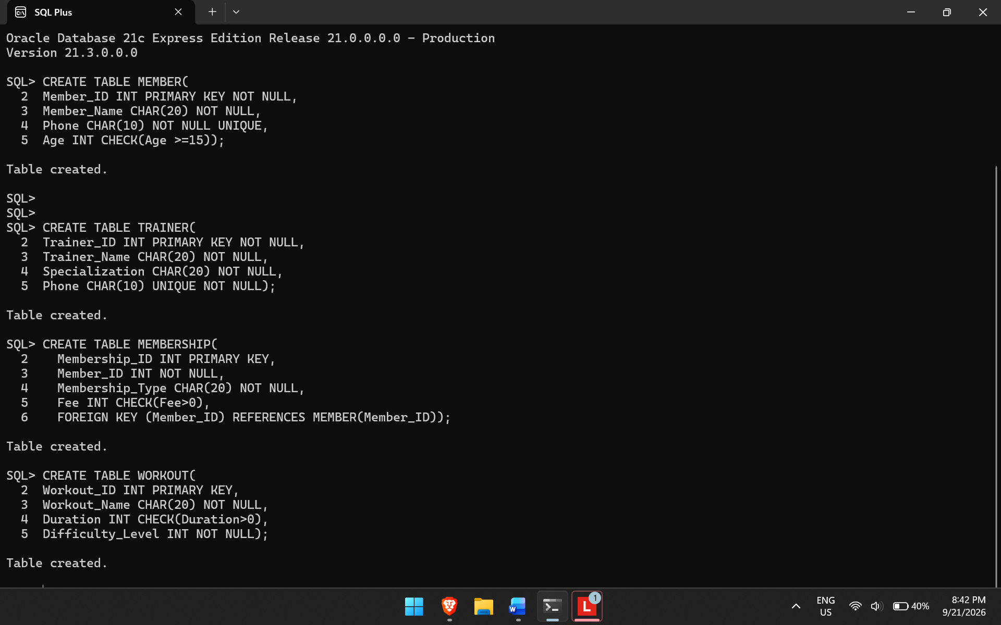
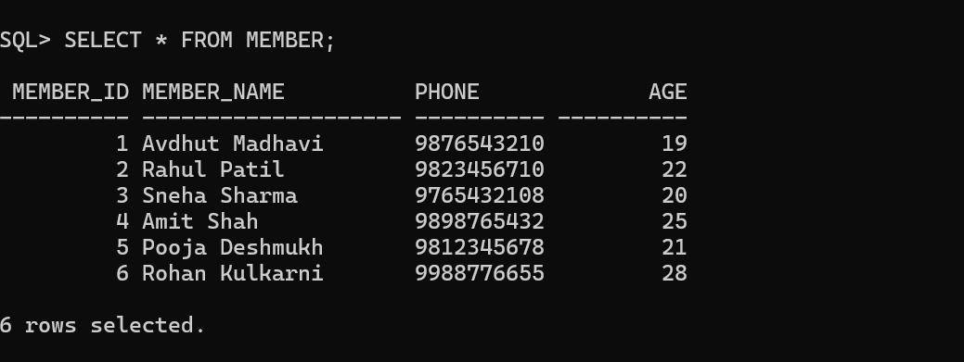

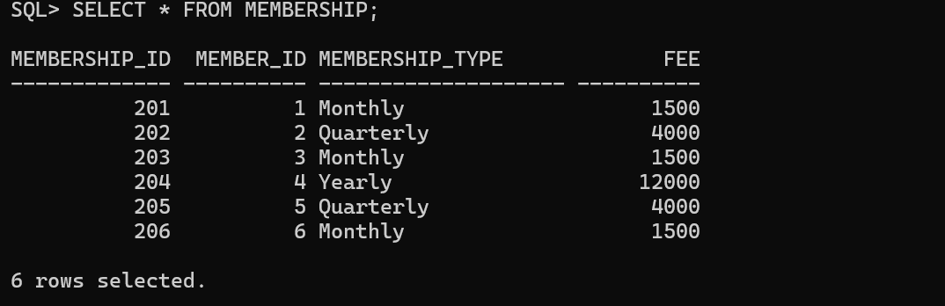

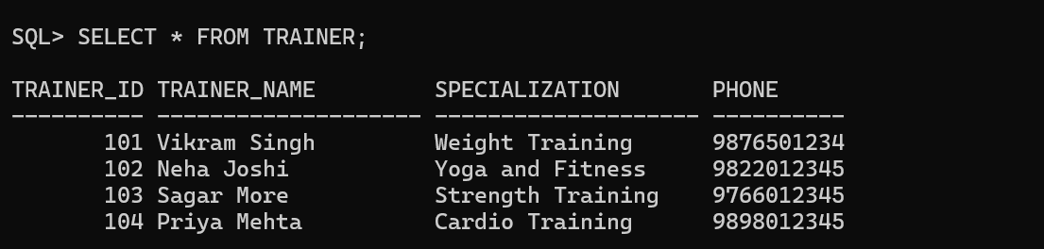
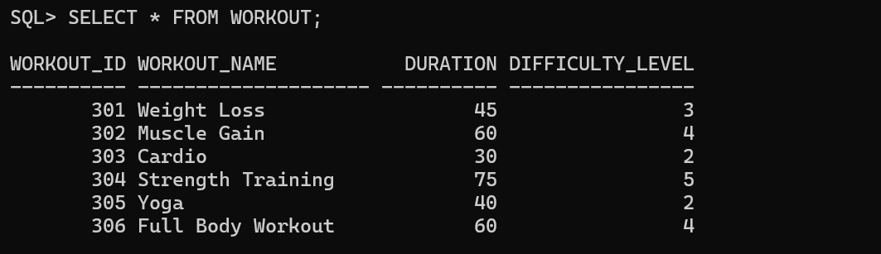

B.2: Write an observation according to the query execution

Observation :

All the SQL queries were performed successfully without encountering any errors. The practical provided hands-on experience with CREATE, ALTER, DROP, and TRUNCATE commands, helping to understand how database tables can be created, modified, removed, and managed. Overall, this practical strengthened my understanding of SQL commands and their applications in DBMS.

B.3: Write an answer of the following questions

- What is the difference between the CREATE and ALTER statements?

The CREATE command is used to build new database objects, such as tables, views, and databases. It establishes the structure and layout of the object where data will be stored.

The ALTER command is used to update the structure of an existing database object. It enables users to add, delete, or modify columns and constraints without having to create the table again.

In simple terms: CREATE is used to create a new database object, whereas ALTER is used to modify an existing object's structure.

- Explain the difference between DROP and TRUNCATE statements.

The DROP statement is used to permanently remove a database object, such as a table, including its data and structure. Once an object is dropped, it needs to be created again if it is required in the future.
The TRUNCATE statement deletes all records from a table while preserving its structure. It is useful for clearing existing data quickly while keeping the table available for future use.
In simple terms: DROP removes the entire table along with its structure, whereas TRUNCATE clears all the data but retains the table structure.

- What happens when you use the DROP TABLE command?

The DROP command is used to completely remove a database object, such as a table, including its stored data and structure. After executing this command, the table must be created again if it is needed.
The TRUNCATE command is used to delete all records from a table while keeping its original structure. It provides a quick way to clear the existing data, allowing new records to be added later.
In simple terms: DROP removes the entire table, including its structure, while TRUNCATE deletes only the records and preserves the table for future use.

